

Practices for Secure Software Report

Table of Contents
Document Revision History 3
Client 3
Instructions 3
Developer 4
1. Algorithm Cipher 4
2. Certificate Generation 4
3. Deploy Cipher 4
4. Secure Communications 4
5. Secondary Testing 4
6. Functional Testing 4
7. Summary 4
8. Industry Standard Best Practices 4

Document Revision History

Version | Date | Author | Comments
1.0 | 4/18/2026 | Valari Alley

Client



Instructions

Submit these complete practices for secure software report. Replace the bracketed text with the relevant information. You must document your process for writing secure communications and refactoring code that complies with software security testing protocols.

- Respond to the steps outlined below and include your findings.
- Respond using your own words. You may also choose to include images or support materials. If you include them, make certain to insert them in all the relevant locations in the document.
- Refer to the Project Two Guidelines and Rubric for more detailed instructions about each section of the template.

Developer
Valari Alley

Algorithm Cipher

Artemis Financial requires a robust encryption strategy for its long-term archive files to protect sensitive financial data from unauthorized access and ensure regulatory compliance. After reviewing the current threat landscape and the Java Security Standard Algorithm Names, I recommend implementing the Advanced Encryption Standard (AES) with a 256-bit key (AES-256) in Galois/Counter Mode (GCM) for file encryption, supported by SHA-3 for data integrity.
For the protection of the archive files, I recommend AES-256-GCM. AES is the industry standard for symmetric encryption, and the 256-bit key level provides the top-secret grade security required for financial institutions. By using GCM, the system provides both confidentiality and authenticity. This prevents “bit-flipping” attacks where an attacker alters the encrypted data without knowing the key.
The primary risk of this recommendation is Key Management. If the secret key for a 10-year-old archive is lost, the data is permanently unrecoverable. While AES_256 is currently secure, the emergence of large-scale quantum computing could theoretically reduce its effective security. However, 256-bit keys remain widely considered quantum-resilient for the foreseeable future.
This cipher will be used to encrypt entire file objects before they are moved to long-term storage. AES is the best choice because it is computationally efficient, allowing for the encryption of large datasets without significant CPU overhead. While RSA is more secure for identity verification, it is thousands of times slower than AES and unsuitable for bulk file encryption. We might choose a slightly less secure path, like not using the absolute newest post-quantum algorithms to ensure long-term compatibility; if we use obscure algorithms today, we risk not having the software capable of decrypting it in the future.
A hash function, such as SHA-3 (Secure Hash Algorithm 3), converts data into a fixed-length string of characters. In our architecture, we use SHA-3 to verify that the archive file has not been corrupted or tampered with over time. The bit level refers to the length of the output; higher bit levels exponentially increase the difficulty of a collision. Encryption relies on Cryptographically Secure Pseudo-Random Number Generators (CSPRNG) to ensure keys are unpredictable.
Encryption has evolved from the ancient Caesar Cipher to the complex DES (Data Encryption Standard) of the 1970s. DES was eventually broken by brute force due to its short 56-bit key. Its successor, AES, was selected by NIST in 2001 after an international competition. Today, we are in the Post-Quantum Transition phase, where the industry is moving toward larger key sizes and sponge-based constructions (like SHA-3) to stay ahead of evolving computational power.

Certificate Generation
Insert a screenshot below of the CER file.

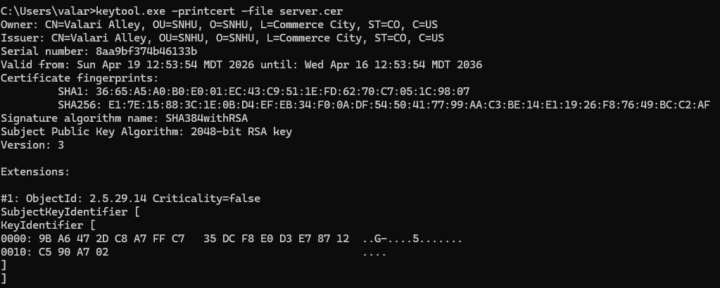

Deploy Cipher
Insert a screenshot below of the checksum verification.

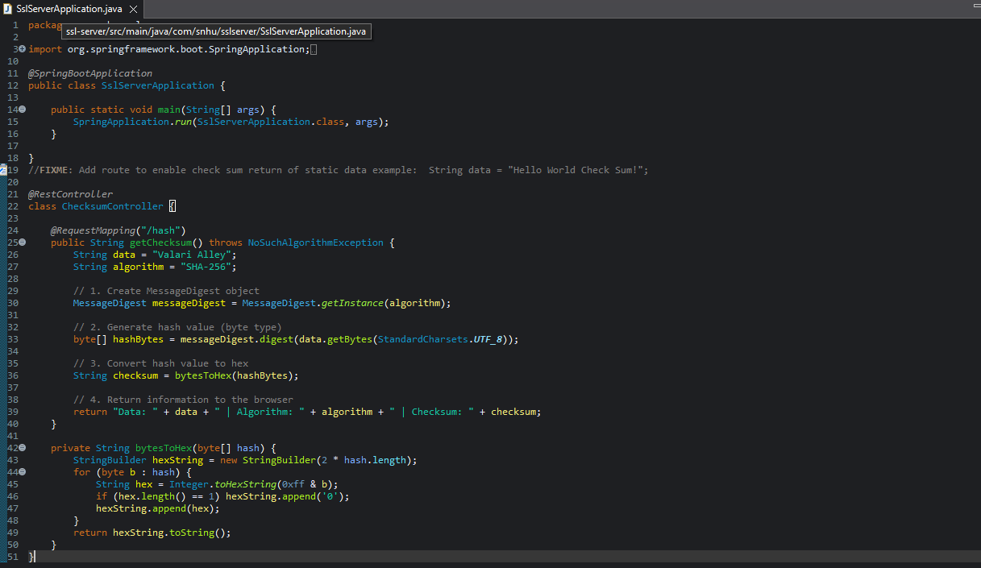
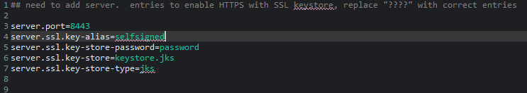

Secure Communications
Insert a screenshot below of the web browser that shows a secure webpage.
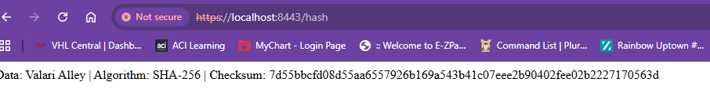

Secondary Testing
Insert screenshots below of the refactored code executed without errors and the dependency-check report.

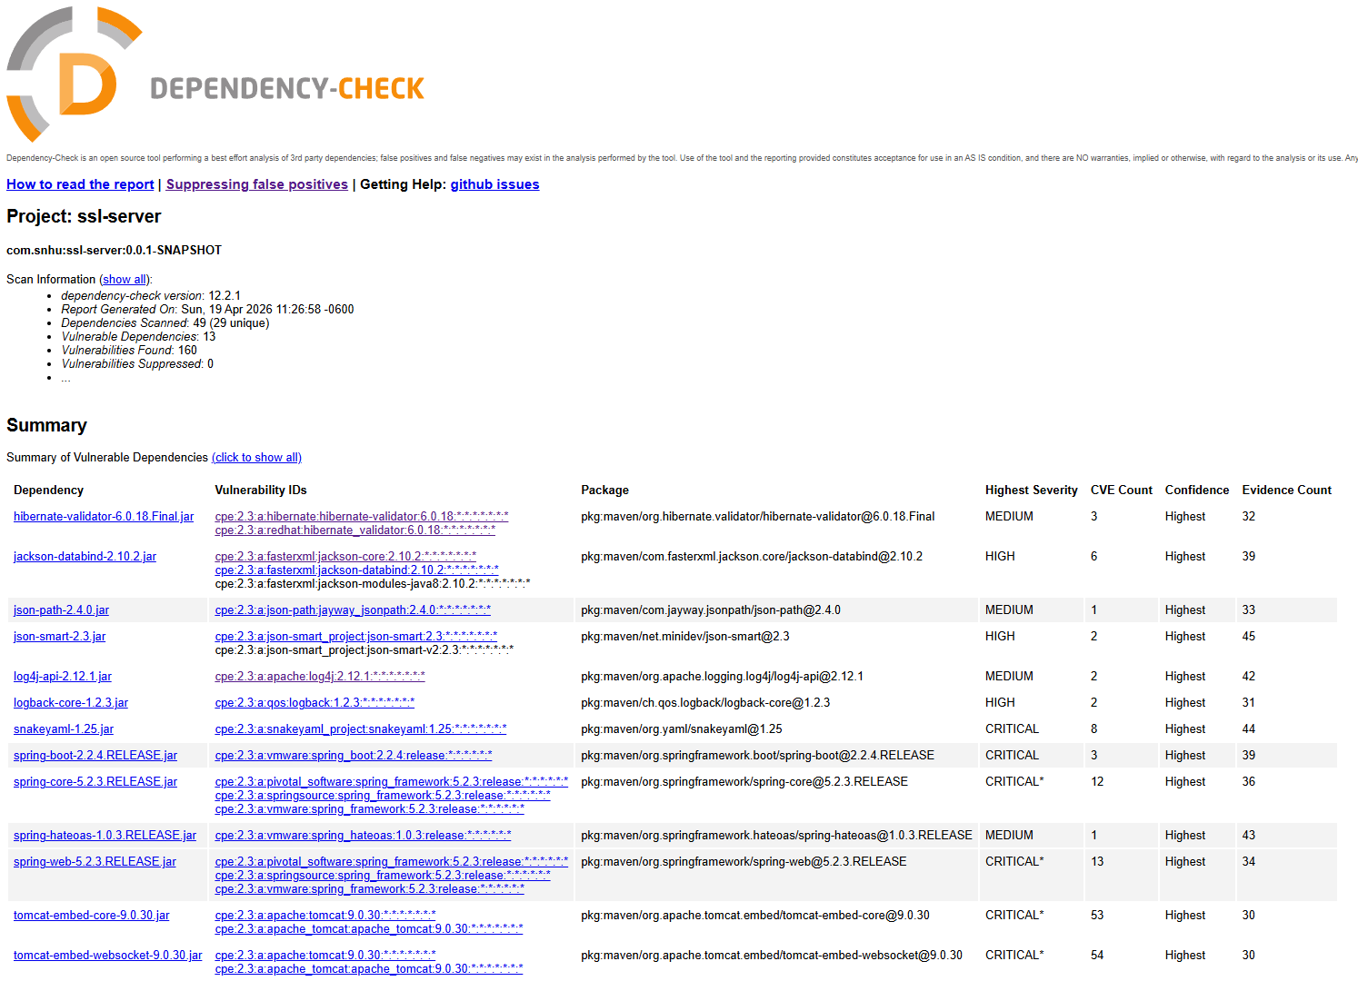
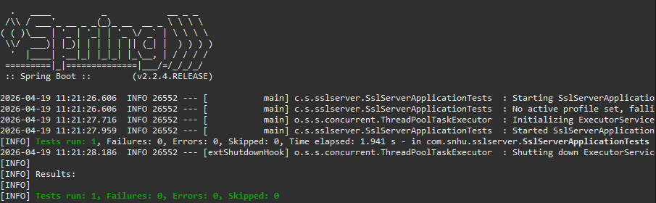

Functional Testing
Insert a screenshot below of the refactored code executed without errors.

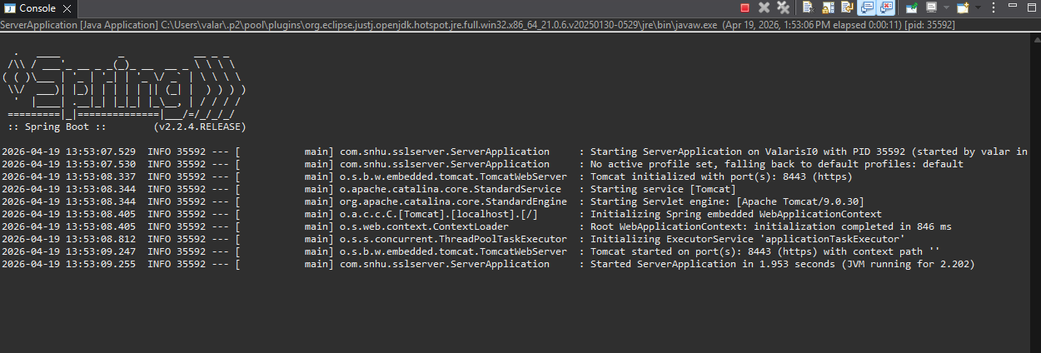

Summary
The refactoring process for Artemis Financial’s application focused on establishing a "Defense in Depth" posture by addressing critical vulnerabilities in data integrity and confidentiality. Following the vulnerability assessment process flow, the primary areas addressed were the transport layer and data verification. The code was refactored to replace insecure HTTP communications with HTTPS, ensuring that all data in transit is encrypted using the TLS protocol. Additionally, a REST endpoint was implemented to generate a SHA-256 cryptographic checksum. This provides a layer of data integrity, allowing the client to verify that a file or data string has not been altered by an unauthorized party during transmission. My process involved updating the pom.xml to include the OWASP Dependency-Check plugin to scan for known vulnerabilities in external libraries, ensuring that the security layers added did not introduce "supply chain" risks. By integrating these changes, the application now complies with modern security testing protocols and protects sensitive financial information from common exploits like man-in-the-middle (MITM) attacks.

Industry Standard Best Practices
I applied industry-standard best practices, such as those defined by OWASP and NIST, to maintain and enhance the application’s security. Specifically, I utilized the principle of Least Privilege and Secure Defaults by configuring the server to require SSL/TLS (HTTPS) by default, rather than leaving it as an optional setting. To maintain the software’s existing security, I performed a static analysis using the Maven dependency-check tool to identify and remediate any outdated or vulnerable dependencies within the Spring Boot framework. Applying these best practices is vital to Artemis Financial’s overall well-being because it mitigates the risk of catastrophic data breaches that could lead to financial loss, legal liability, and irreparable damage to the company’s reputation. By following a standardized security lifecycle, including manual code reviews, automated testing, and the use of modern cryptographic algorithms like SHA-256 the company ensures its operations remain resilient against evolving cyber threats.

